**Gantt Chart:**

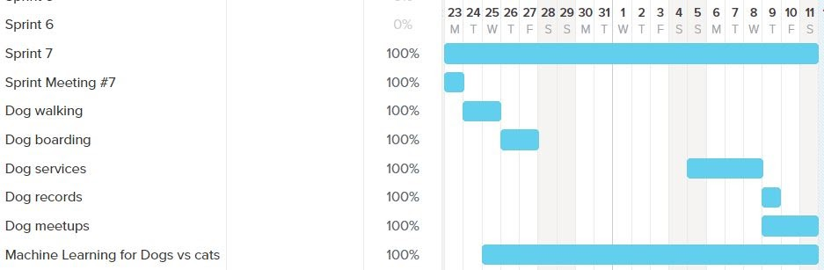

**Sprint Goal:**

Work on all the features pages. Run tests on all features pages to find and fix bugs. Research and find the dataset for dogs and cats. Work on machine learning model for cats vs dogs.

**Sprint Retrospective:**

We finished the tasks that we planned for this sprint. We planned 22 story points this sprint where everyone in the group contributed 4 hrs. per week for 3 weeks. We assigned the right amount of tasks for this sprint considering the time for transitioning to working from home and one week of spring break during this sprint. In the next sprint, our team should schedule regular online meetings. We should spend more time on working on the machine learning model. We decided the user stories to work on based on which pages lacked quality. The burndown chart did not look linear because we had the spring break in middle of the sprint. Researching and working with the machine learning model consumed a lot of time.